Business Analysis Internship
Task 3
Exploratory Data Analysis (EDA)

Name: Adeel Khan
Role: Business Analysis Intern
Company: Saiket Systems

- Objective:
The objective of this task is to explore the customer dataset using statistical measures and visualizations to identify patterns related to monthly charges and customer churn.
- Dataset:
Telco Customer Churn Dataset
Column analyzed: monthlycharges
- Tools Used:
• Python
• VS Code
• Pandas
• Matplotlib
- Histogram Analysis
A histogram was created to understand how monthly charges are distributed among customers.
The visualization shows that customers are grouped into low and high charge ranges rather than being evenly distributed.
- Box Plot Analysis
A box plot was used to analyze the spread of monthly charges.
It highlights the median, range, and extreme values, helping to understand billing variability among customers.

- Churn Comparison Analysis
Monthly charges were compared between churned and non-churned customers using box plots.
This comparison helps identify whether higher monthly charges are associated with customer churn.

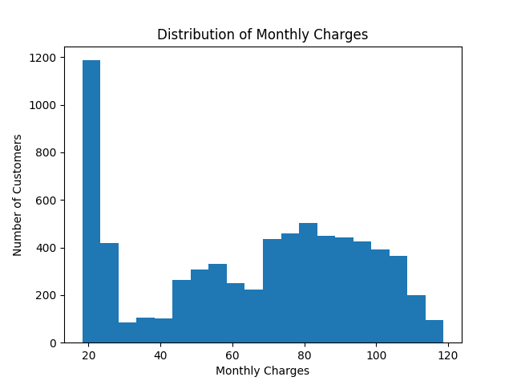
- Visualizations:
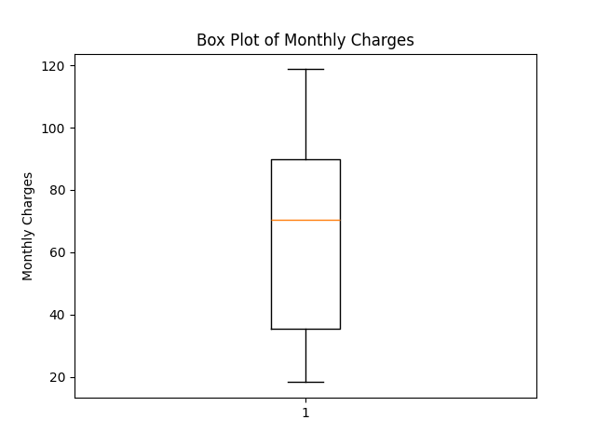
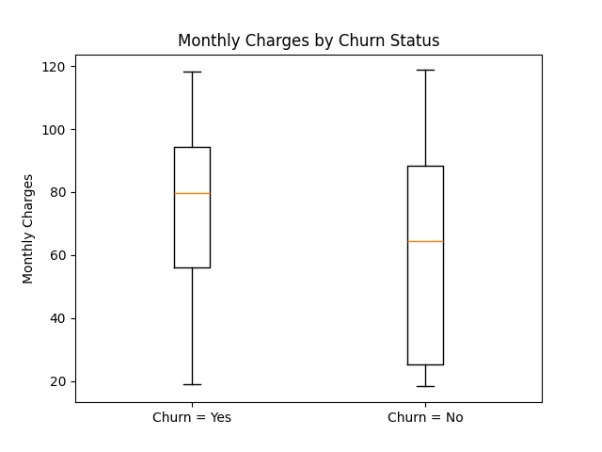
- Key Insights:
• Most customers fall into low and high monthly charge groups.
• Customers who churn tend to have higher monthly charges.
• The median monthly charge for churned customers is higher than for non-churned customers.
• Very high monthly charges may increase churn risk.

- Conclusion:
Exploratory Data Analysis helped in understanding customer billing patterns and their relationship with churn.
The insights gained from this task can support better pricing and customer retention strategies.

